On behalf of HULL CITY COUNCIL
____________________________________________ (setting name)
REQUEST FOR EDUCATIONAL PSYCHOLOGY INFORMATION/ADVICE TO SUPPORT THE DEVELOPMENTOF AN EDUCATION, HEALTH AND CARE PLAN FOR A CHILD/YOUNG ADULT

This information is sought in accordance with the Children and Families Act 2014. The Local Authority is seeking advice as part of an Education, Health and Care assessment. The school are commissioning this and will provide the advice to the local authority in support of the statutory assessment request.

Name | Date of Birth | Gender
School/Setting | Date of Report (must be within 6 months of EHCNAR)

This report has been written by:
Name | Signature
 | 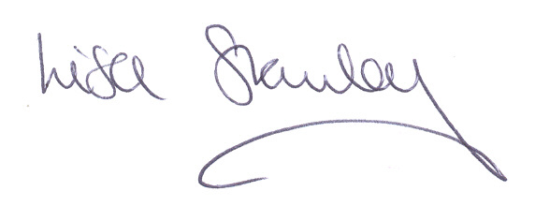
Designation: Educational Psychologist (mandatory qualification)
MUST BE HCPC Registered
Summary

Relevant Background Information

Current Assessment of Strengths (overall)

Current Assessment of Needs (broken down into the broad areas of need)

Cognition and Learning

Communication and Interaction

Social, Emotional and Mental Health

Sensory, Physical and Medical

Outcomes

The following outcomes are suggested in response to the strengths and needs described above.

By the end of key stage will be able to:

Provision

Universal Provision- these are detailed in the Local Authority’s Graduated Approach guidance - Hull Graduated Approach (local offer).

F1. SEN Support Targeted Provision- targeted provision that can be delivered as part of the school’s SEN support offer under their ‘best endeavours’ duty (roughly 6 hours of targeted support).

F2. EHCP Provision - that is additional and different beyond the ordinarily available SEN support and needs to be secured by an EHCP.

